
Consent Form (Groups)

Please complete this form, save it and email it to booking@lewis-school.co.uk. Please also print this form, sign it, and make sure you travel with it as you may need to show it at border control at the airport.

Emergency contact: +44 7730 747619.

Group Details
Name of Group
Name of Group Leader(s)
Dates of Study | from dd mm yyyy to dd mm yyyy
Studying at - please tick (✓) |  | Lewis School (Adults & Year-Round Juniors)  Lewis School of English, 30-33 Palmerston Road, Southampton SO14 1LL
Southampton Summer Junior Centre
Solent University, East Park Terrace, Southampton SO14 0YN
Reading Junior Centre
University of Reading, Whiteknights, Reading RG6 6AH
New Forest Junior Centre
Ringwood Waldorf School, Folly Farm Lane, Ashley, Ringwood BH24 2NN
Guildford Junior Centre
Gordon’s School, Bagshot Rd, West End, Woking GU24 9PU

Travel Details
From/to (airport/station) | from | to
Date of travel (dd/mm/yyyy) | dd mm yyyy
Flight Number

Students in My Group
Please provide full names

Parent / Guardian Consent
Please select ‘Yes’ or ‘No’ to indicate where you have received written consent from parents/guardians.
If there are exceptions within the group, please tick ‘See notes’ and provide details on the next page. If you have indicated ‘No’ for any answers, please also give details on the next page.
Where ‘Yes’ is marked with an asterisk (*), consent is a requirement of the programme.
Travel
I have received written parent/guardian consent for the children in my group to travel to the UK to attend an English language course at the Lewis School of English in the centre indicated. | Yes* | No | See notes
Accommodation
I have received written parent/guardian consent for the children in my group to stay in the accommodation specified on the booking form. The students understand that they must follow the school and house rules, and curfew times, as specified in the Pre-Arrival Guide. | Yes* | No | See notes
I have received written parent/guardian consent for the children in my group to travel between the school and their accommodation. Please refer to your booking confirmation for location, travel time and distance. | Yes* | No | See notes
If any students in my group are aged under 16 and are staying for more than 27 nights, I have received parent/guardian consent for the Local Authority Social Services to be informed, and will provide information as required by them. Visits by children under the age of 16 must comply with Social Services Private Fostering Legislation. | Yes | No / Does not apply | See notes
Attendance & Participation
I have received written parent/guardian consent for the children in my group to participate in the advertised activity programme, available on the Lewis School website. This may including travelling on public transport under the supervision of Lewis School staff. | Yes* | No | See notes
Parents/guardians understand that their child is expected to attend all scheduled classes and activities and to be in their accommodation at the stated time. I understand that any planned absence must be requested in advance and authorised by centre management, and absentee form must be completed. | Yes* | No | See notes
Supervision
Parents/guardians understand that there are moments of unsupervised time on the programme, such as shopping time on trips, gaps between activities/lessons/meals, and the period before bedtime in the residence. During these times, staff will be close by and will be available if any assistance is required. | Yes* | No | See notes
Health
In the event of an accident or medical emergency, the parent(s)/guardian(s) have also given written consent for Lewis School and / or the homestay host to arrange for emergency admission to a local hospital for medical or dental treatment, including the use of anaesthetics. NB: It is a requirement of the Department of Social Security that we have the written permission of parents/guardians to act in loco parentis if emergency treatment is required. | Yes* | No | See notes
I have received written parent/guardian consent for basic first aid or over-the-counter medicines to be administered to the children in my group by Lewis School staff or the homestay host. | Yes* | No | See notes
Photographs & Video
I have received written parent/guardian consent for my photographs or video clips of the children in my group to be used in Lewis School publicity, including social media. The school will also ask for the child’s consent. | Yes | No | See notes

Notes
Please provide details where you have indicated ‘No’ or ‘See Notes’ on the previous page.

Details of Agency / Group Leader
Name of Agency / Leader
Address of Agency / Leader
Telephone
Signature
(not required if sending by email)
Please Print Your Name
Date | dd mm yyyy

After You Have Completed This Form

 | Email it to booking@lewis-school.co.uk.
 | Print a copy for you / your group leader to take on the plane.
 | IMPORTANT: Ensure you / your group leader child travels with this document.  You may need to show it to border control at the airport. Emergency contact: +44 7730 747619.

Thank you.
Lewis School of English, 30-33 Palmerston Road, Southampton SO14 1LL, UK. lewis-school.co.uk

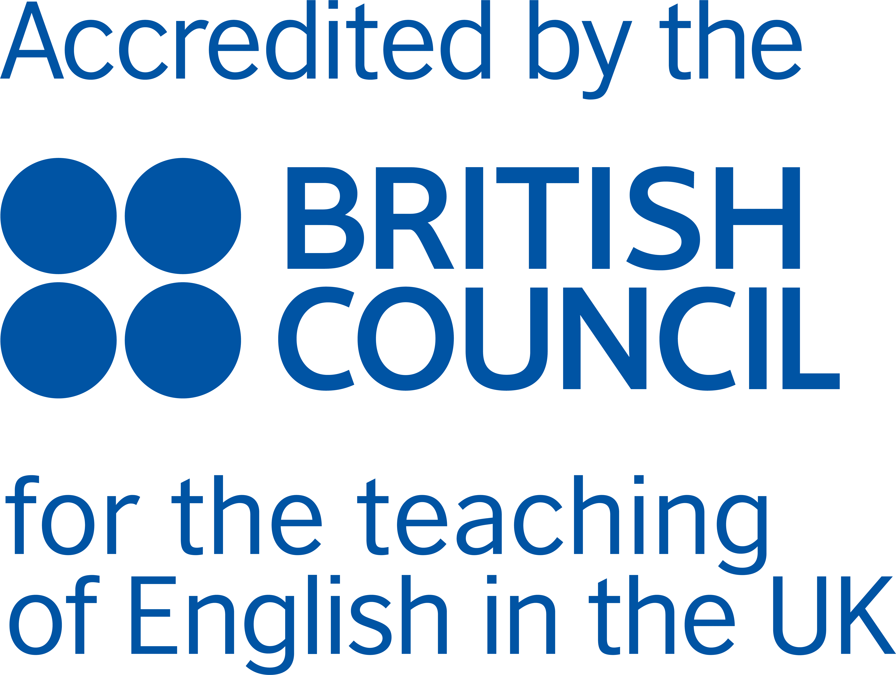 |  |  | 

