Training Visit

Select the relevant boxes and write comments in the greyed out areas.

What activities* do you want to include in your Training Visit? Select as many as you wish
Management | Teachers | Students |  |  | Curriculum |  | Resources
☐ Arrival meeting | ☐ Pre-observation | ☐ All ages |  |  | ☐ Review  syllabus |  | ☐ Classrooms
☐ School tour | ☐ Lesson observation | ☐ Free English lesson |  |  | ☐ Review coursebooks |  | ☐ Staff room
☐ Updates per day | ☐ 1:1 lesson teacher feedback | ☐ Placement / Progress test |  |  | ☐ Review exam structures |  | ☐ IT & other equipment
☐ Final presentation | ☐ Free Teacher training workshop | ☐ Q&A |  |  | ☐ Check assessment process |  | ☐ Internet resources
* Pages 2 & 3 provides descriptors of each of the activities listed above

How many days would like us to come for? |  |  |  |  | ☐ 2 days ☐ 3 days* ☐ 4 days*
* 2-day consultancy visits are free. However, the client will need to pay travel and accommodation for the training specialist(s). For every extra day an additional fee of £190 will be charged (payable 14 days before arrival)
When would you like us to arrive and begin? |  |  |  |  | Click here to enter a date.
FREE English lesson for students |  |  | How old are the students that we will be teaching?
☐ Ages 9-12 ☐ Teenagers ☐ University students ☐ Adults ☐ Other (please specify)
How many students will be in the group? |  |  |  | ☐ 6-12 ☐ 13-20 ☐ 21-28
Briefly describe what you want the lesson to involve:

FREE teacher training workshop |  |  | What do you want the training session to involve?
Training Topics |  |  | 1 = Very important.  We need this. |  |  | 2 = Quite important.  This would be useful. |  | 3 = Less important,  but I am interested.
Exploring Continuing Professional Development (CPD*) |  |  | ☐ |  |  | ☐ |  | ☐
Student-Centred Teaching Techniques |  |  | ☐ |  |  | ☐ |  | ☐
No-materials lessons |  |  | ☐ |  |  | ☐ |  | ☐
Humanising course books |  |  | ☐ |  |  | ☐ |  | ☐
Post-method era |  |  | ☐ |  |  | ☐ |  | ☐
Classroom Layout & Dynamics |  |  | ☐ |  |  | ☐ |  | ☐
Something else? Briefly describe here…

Thank you. Please save this form and email it to info@lewis-training.co.uk.

The next pages offer outlines of each of the twenty activities your consultancy visit could include.
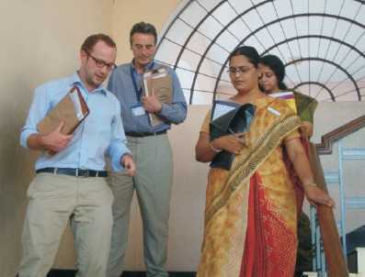
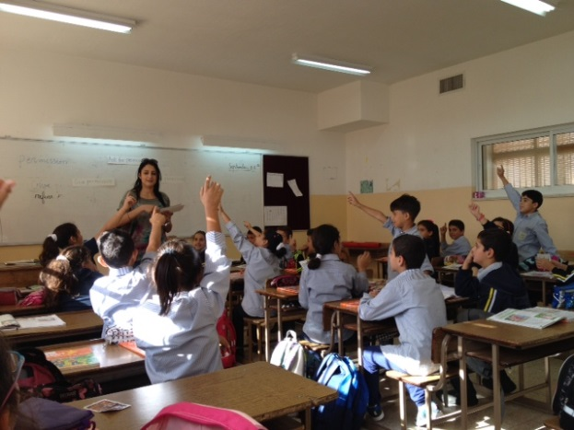

~ Training Visits to India in 2013 and the Middle East in 2014

Activity Descriptors
Training Topics | Descriptors
Arrival meeting | This meeting sets the tone for our visit, introducing ourselves to one another and identifying key personnel (including IT technicians and caretakers who have proven to be vital parts to efficient consultancy visits in the past!). We will go over the itinerary to check for unforeseen issues so that they can be anticipated and dealt with beforehand, and it’ll be an opportunity for you reiterate your desired outcomes from our visit.
School tour | To understand the context of teaching and learning at your school, a tour would be an excellent starting point. The physical environment plays a key role to learning so the sooner we gain that ‘picture’ the better. During the tour we’d want to be shown where the staff rooms, English department, English language classrooms, emergency exits, and washrooms are.
Updates per day | At the end of each day we can reconvene to run over our experience and findings from that day, so that you are kept up-to-date throughout. There may be the need to adjust the plan (either by you or us). An effective visit requires careful reflection and some flexibility on both sides.
Final presentation | At the conclusion of our visit we would be happy to present our initial impressions of your teaching operations and pedagogy. Please note that this will not be comprehensive, as we would then need to revise our notes upon our return to the UK, which would be closely followed by the submission of a concise report to you (via email).
Pre-observation | Before observing teachers we would like to speak to them altogether (informally) and would need no more than 30 minutes of their time. We feel it is a necessary element to observations as we can assuage any fears or preconceptions so that the teacher can focus on their teaching as opposed to the stranger sitting at the back of their room! It also offers other opportunities in preparation for the observations. If you’d like to find out more about this, please let us know.
Lesson observation | This is arguably the most useful element to the consultancy visit. Being able to witness the teachers and students in action gives us the most direct access to identifying areas for development, as well as strengths (which are as important – identify them so that they can be exploited more often). It will also help us plan better for the teacher training workshop.
1:1 lesson teacher feedback | Individual feedback for teachers after observations is a must. By listening to the teachers’ rationales behind the decisions they made throughout the lesson, we gauge a better understanding of the pedagogy employed. The process helps teachers to become more self-aware and reflective of their teaching. Self aware teachers are often the stronger teachers.
Teacher training workshop | The workshop can be up to 2 hours long – it is your choice. Our sessions are far-removed from being a lecture format. They are interactive and for good reason: it enables teachers to consolidate these new tools, techniques and/or approaches before the end of the session, and in a way that empowers them to immediately start experimenting from their very next lesson onwards. Theory is one thing, practice is quite another!
All ages | Which age groups would you like us to focus on? If the answer is all of them then fine, but there is only so much we can do in 2 – 4 days. If you have an age group that requires more attention than others, let us know, so that we can be more useful where it matters the most. For example, perhaps your older students seem to have lost interest in learning English, whereas younger students seem motivated. Use us to help find solutions. It is what we do best!
Free lesson | We would be happy to teach a lesson to your students. 1) It would give us an insight into the students you are teaching; 2) we can experiment with methods we may eventually be advising you to employ, which will help our needs analysis further; 3) it would make a change for your students and give them the opportunity to practise with native speakers.  Please note: we are happy for our lesson to be recorded for later viewing. We can also allow a maximum of 2 observers in the room during the lesson.
Placement/ Progress test | We can assess a cross-section of your students to ascertain their general English language levels, and therefore language development needs. This would by no means be a comprehensive assessment, but more an opportunity to identify the more obvious language needs. The test would be in the form of a speaking test (5 minutes) and a written paper (multiple choice). This will have implications on our final report, which should always consider the learners themselves. After all, that is what it’s all about.
Q&A | This Question & Answer session can either be with either students, teachers or management. If management, then submit a list of questions on day 1, so that our activities focus on delivering those answers at the end of our visit e.g. What is the most cost-effective change we could immediately implement? If teachers, then see this as a responsive training session where teachers get to ask questions that matter to them. If students, perhaps it’s an opportunity for them to learn about a different culture or simply to listen to English spoken by native speakers.
Review syllabus | We would be eager to evaluate your scheme of learning and identify strengths therein, and perhaps elements to it that could be modified to help students learn more effectively and teachers teach more responsively. We will of course consider the examinations that they are designed to prepare students for. However, accomplishment in learning a language is far from being just about exams. We consider how the syllabus can encourage real language acquisition so that students are able to function in English speaking environments.
Review coursebooks | Course books are mistreated the world over – we realise this is a strong claim! However, we have witnessed this too often to shy away from this seemingly global epidemic. A course book is a very effective tool for learning and teaching (we wouldn’t want to be without them), but they shouldn’t be treated as the syllabus and main stimuli for learning. This consultancy service can lead to quick development in teaching and learning.
Review exam structures | By gaining an insight into your examinations, we are able to accurately assess teaching practice. Does your school’s teaching approach effectively prepare students for the exams? How can it be improved upon? This service considers these questions among others.
Check assessment processes | We can review what assessment procedures you currently use and the criteria within each. Why? To define key features that are working (i.e. are measurable) and perhaps make recommendations as to areas to consider so that progress through assessment is a constant.
Classrooms | Classroom design and layout influences learning in a multitude of ways. We can evaluate their design and use and suggest ways of changing the space so that learning is more vibrant, collaborative, and conducive to all individuals (aka students).
Staff room | The staffroom is the heart to any school. It is therefore paramount that the space be designed and used correctly. If there are recommendations to be made on how the room can operate more efficiently, we have a host of very cost-effective ways to implement such changes.
IT & other equipment | …In the classroom and staffroom. We will observe how IT is used to aid learning and operational procedures (among teachers only). We would include recommendations within the report.
Internet resources | By the end of our visit or within our report we can advise on various internet resources that will further compliment your teaching practice - based on our findings. Very often these resources are free and therefore it is a very cost-effective way to improve learning environments.

~ Training Visit to Turkey in 2012

